

Version 2.0
FEBRUARY 2026



APPENDICES

APPENDICES

Appendix 1 Drivers declaration

Appendix 2 Parental Consent – Transport in another adult’s vehicle and Activity Consent Form

Appendix 3 Educational Visits Flowchart

Appendix 4 STAGER Model

Appendix 1
Volunteer Driver’s Declaration
PRIVATE CAR
FORM

To: The Headteacher …………………..………….………..School ……………………………………………………………
I confirm that I am willing to use my own vehicle for transporting students on Educational Visits.
I accept responsibility for maintaining appropriate insurance cover and have checked with my insurance company that students carried voluntarily are insured.
I have a current clean, valid driving licence.
I shall ensure that the vehicle is roadworthy in all respects.
I shall ensure that all passengers wear correctly fastened seat belts.
I will transport young people in line with the establishment’s safeguarding and lone working policy.
I shall at no time transport a single student, other than my own child, as part of any journey. (This section does not apply to any 17/18/19-year-old student transporting their peer).
I agree to the terms and conditions outlined in this declaration and will operate within them. I have never been interviewed, cautioned, or convicted of any offence that would render me unsuitable to work with young people.
I shall at no time transport a student or students while I am under the influence of alcohol or drugs.

Signed: ………………………………………………………
Date: ……………………………..

Name and address: …………………………………………………………………………….
……………………………………………………………………………………………………………

The Employer reserves the right at any time to request copies of any relevant documentation, including vehicle registration or ownership document, MOT certificate, insurance certificate, road tax or driving licence.
Persons regularly transporting children will be asked to provide any disclosure certification required by the school or employers' policy. This is to ensure that they have not been declared unsuitable to work with children and young people.
Drivers should retain a copy of this declaration reminding them of the school’s expectations.

 | Insurance cover required
For teachers, youth workers, or other LA employees | ‘Use by the Policyholder in connection with the business of the Policyholder’
For parents and other volunteers | ‘Use for social, domestic and pleasure purposes’

PRIVATE CAR
FORM
Appendix 2
Parental Consent Form for a Student to be Transported in Another Adult’s Vehicle
Schools may wish to obtain parental permission for students to be transported in other adults’ cars by the use of a proforma such as this:
There may be occasions when your child could be transported in the car of another adult associated with the school.
The conditions under which other adults agree to provide use of their car are as follows:
They:
- confirm they are willing to use their own vehicle for transporting students on Educational Visits
- accept responsibility for maintaining appropriate insurance cover and have checked with their insurance company that students carried voluntarily are insured.
- have a current clean, valid driving license.
- shall ensure the vehicle is roadworthy in all respects
- shall ensure all passengers wear correctly fastened seat belts
- will transport young people in line with the establishment’s safeguarding and lone working policy.
- shall at no time transport a single student, other than their own child, as part of any journey (this section does not apply to any 17/18/19-year-old student transporting their peers)
- agree to the terms and conditions outlined in this declaration and will operate within them
- have never been interviewed, cautioned or convicted of any offence that would render them unsuitable to work with young people
- shall at no time transport a student or students while they are under the influence of alcohol or drugs.

I give permission for my son/daughter/ward ……………………………………………… to be transported in the car of another parent within the requirements explained to me.

Signed: …………………………………………………… Date: …………………………………..

Name and address: ………………………………………………………………………………..
……………………………………………………………………………………………………………….

EMERGENCY CARD
(VISIT LEADER)
Appendix 2

PARENT / GUARDIAN CONSENT FORM FOR ACTIVITIES OUT OF NORMAL SCHOOL HOURS

Visit: Adventure residential September 2023
Establishment/Group: School name
Details of Visit to:
I agree to __________________________________ (name) taking part in this visit
I have read the information sheet and I agree to __________________ ‘s participation in the activities described.
I acknowledge the need for ________________________________to behave responsibly throughout the visit.

- Medical information about your child

a) Any conditions requiring medical treatment, including medication? YES/NO
If YES, please give brief details:

- Please outline any food or other allergies and special dietary requirements of
your child:

- Any recent illness or accident staff should be aware of?

- The type of pain/flu relief medication your child may be given if necessary:

For activities based in or near water
The following information will assist the Party Leaders in caring for your child.
- Can your child swim? YES / NO
- Can your child swim 25m? YES / NO
- Is your child confident in the pool? YES / NO
- Is your child aware of the dangers of deep water? YES / NO

For residential visits and exchanges only
e) To the best of your knowledge, has your child been in contact with any contagious or infectious diseases or suffered from anything in the last four weeks that may be contagious or infections? YES/NO
If YES, please give brief details:

f) Is your child allergic to any medication? YES/NO
If YES, please specify:

g) When did your child last have a tetanus injection?

Declaration
I agree to my child receiving medication as instructed and any emergency dental, medical or surgical treatment, including anaesthetic or blood transfusion, as considered necessary by the medical authorities present. I understand the extent and limitations of the insurance cover provided.
Contact telephone numbers:
Work: Home:
Home address:

Alternative emergency contact:
Name: Telephone number:

Address:

Family doctor:
Name: Telephone number:

Address:

As part of the activities your child / children are involved in the school may take photographs or video footage to use in printed publications or publicity or promotional material including the local press.

Can we use the young person’s photograph in this way? YES / NO

Signed: Date:

Full name (capitals):

THIS FORM OR A COPY MUST BE TAKEN BY THE GROUP LEADER ON THE VISIT. A COPY SHOULD BE RETAINED BY THE ESTABLISHMENT CONTACT

Appendix 3
Educational Visits Flowchart
Note: This process is automatically followed when using EVOLVE
EVCs should make themselves familiar with the OEAP national guidance website. Refer to the relevant section(s) of the National Guidance by using the search facility.
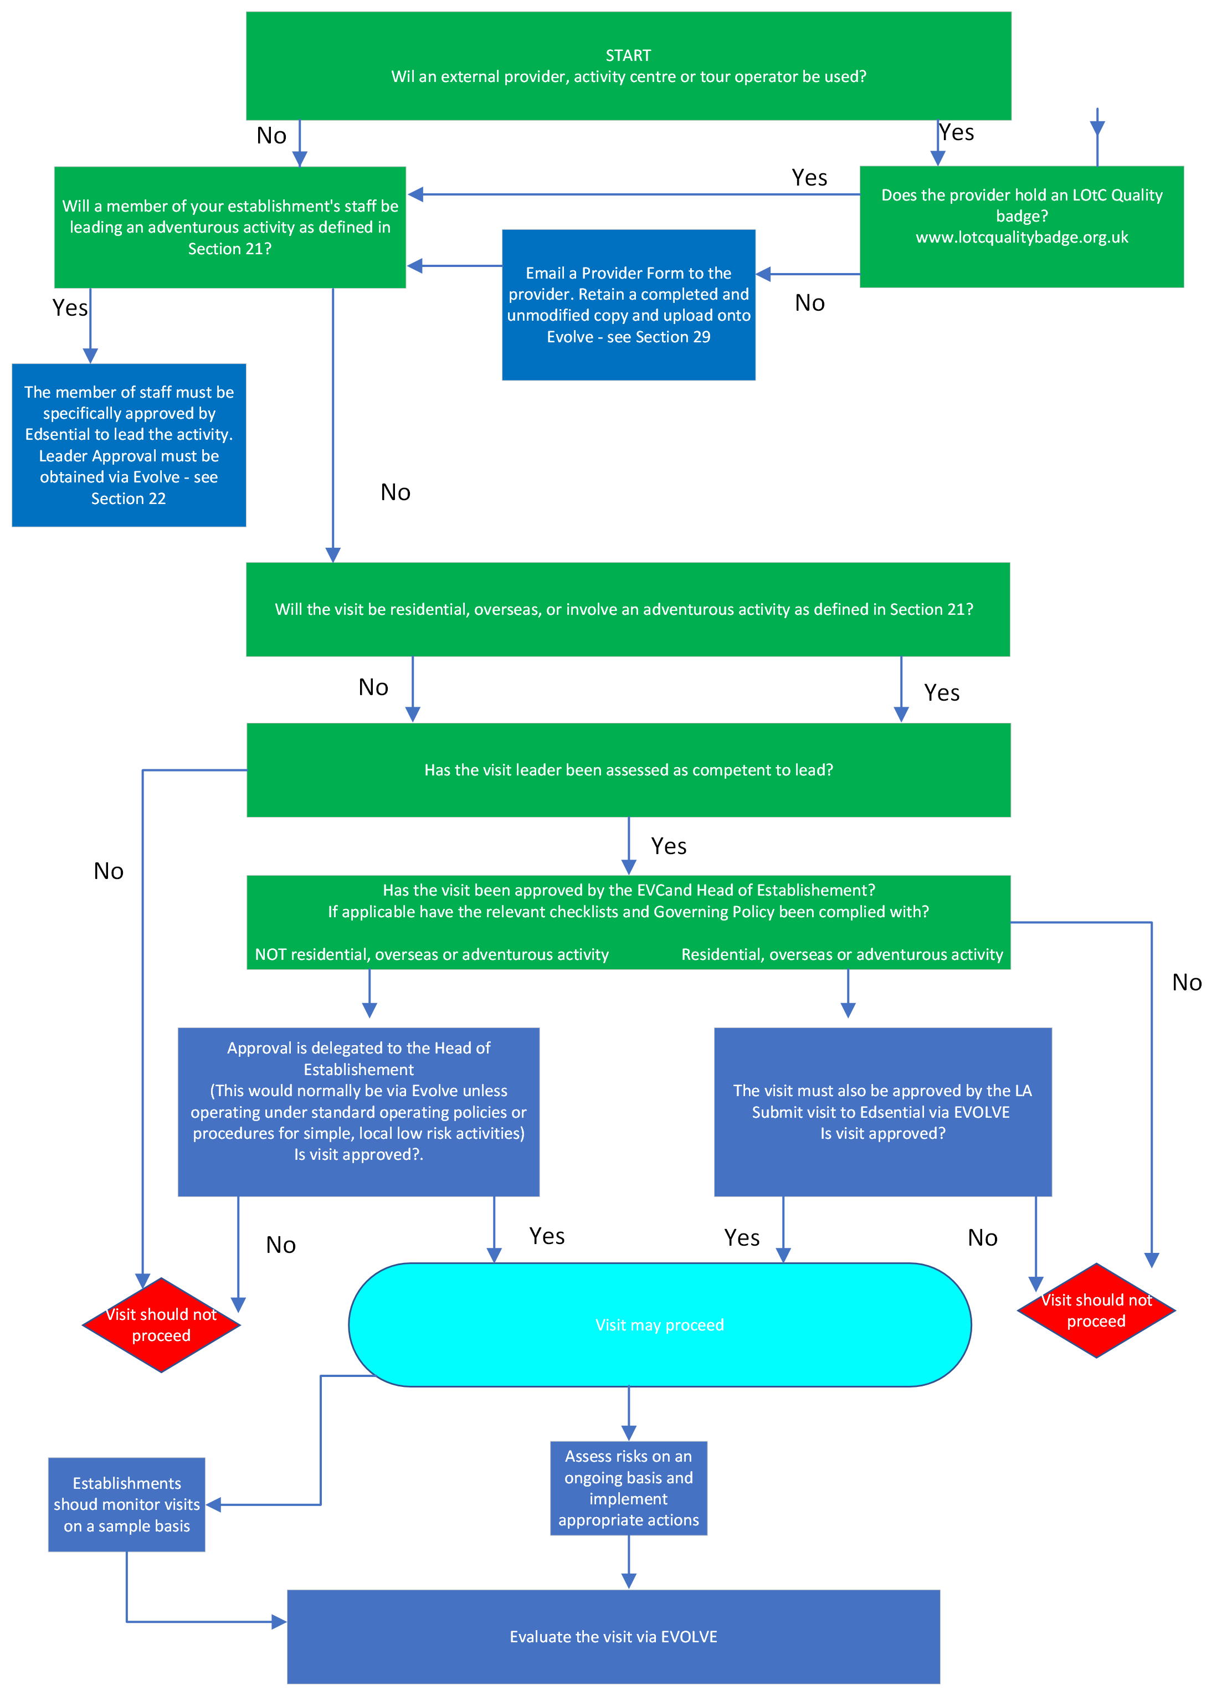
Appendix 4
STAGER Model

A useful framework for assessing requirements for ratios and effective supervision is STAGER. See OEAP National Guidance document 4.3b Ratios and Effective Supervision:
Staffing: who is needed/available? The plan must work within the limits of available numbers, abilities, and experience
Timing: How will the time of year or time of day affect the visit and its staffing? If the visit takes place out of the establishment’s normal working hours, or at a weekend or during holidays, how will this affect staffing and the availability of support back at base?
Activities to be undertaken: what do you want the group to do and what is possible?
Group characteristics: prior experience, abilities, behaviour and maturity, sex, any specific individual needs.
Environment: indoors or out; a public space or restricted access; urban, rural, or remote; quiet or crowded? Do not overlook environments to be passed through between venues. For residential visits consider the accommodation and surrounding area. For outdoor environments, consider remoteness, the impact of weather, water levels and ground conditions.
Distance: do the activities take place within the establishment grounds, close to it or at a distance? Will communications between the group and base be straightforward? How easy will it be to summon help in an emergency, and for emergency services to reach the group?
Do not overlook environments to be passed through between venues:
For residential visits consider the accommodation and surrounding area.
For outdoor environments, consider remoteness, the impact of weather, water levels and ground conditions.
Consider the implications of current guidance about avoiding infection during an epidemic

