BIDSTON AVENUE PRIMARY SCHOOL

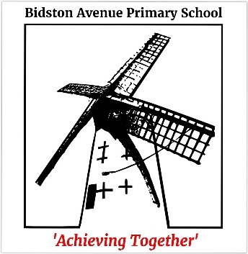
‘Achieving Together’

Tollemache Road, Birkenhead, Wirral, CH41 0DQ
Tel: (0151) 652 1594
Fax: (0151) 653 2064
Email: schooloffice@bidstonavenue.wirral.sch.uk
Web: http://www.bidstonavenue.wirral.sch.uk

HEADTEACHER: Mr. S.G. Brady B.Ed. (Hons), NPQH, FCCT
________________________________________________________________

11th November, 2024

Dear Parents/Carers

‘Let’s have a SPOTacular Children in Need’ on Friday 15th November 2024

We will be supporting the ‘Children in Need’ event on Friday 15th November 2024.

Children are welcome to come to school with spotty clothes, spotty faces, and for the brave why not add some mad hair. But please, do not go to any expense.

Donations can be made via ParentPay.

The ‘Children in Need’ Charity provides grants to support projects in the UK focusing on disadvantaged children and young people. Please help us raise money for this amazing charity.

Article 27 - Children have the right to a good standard of living.

Yours sincerely

S.G. Brady
Headteacher


