8th October 2026
Dear Parents/Carers of Year 6 Children,

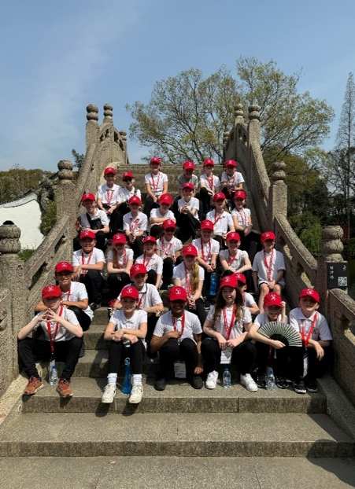
RE: China Visit 2027

We have had five amazing visits to China in 2018, 2019, 2024, 2025 & 2026. We have taken over 100 children to visit our sister school in Taicang, Jiangsu Province, as well as seeing and staying in Shanghai along the way!

The China trip was quoted in Ofsted’s report as, ‘A once-in-a-lifetime opportunity!’, but this year it is even better… we plan to visit Beijing and The Great Wall of China (fingers crossed).

We have been granted some funding this year, but there will need to be family costs, too. The standard cost is £600, with pupil premium children at £300. The standard cost is half of last year’s cost.

This is still significantly cheaper than the full cost of over £2200 per child. We also cannot guarantee a cheaper trip in 2028.

PLEASE NOTE: The trip will include part of the first week of the Easter holiday (March/April 2027).

If you wish your child to be part of the 2027 visit to our sister school in Taicang then please complete the slip below to show a declaration of interest and head to ParentPay to pay your deposit of £50.

Yours sincerely

S.G. Brady
Headteacher
__________________________________________________________________

FAO: Miss Mearns

China Visit 2027 – Parent/Carer Declaration of Interest

I / We are interested in the China Visit 2027.
I / We have paid our non-refundable deposit on ParentPay.

Child’s Name: _________________________________ Class: ___________________

